  Project 1: Perceptron & Adaline  EML 5808 Neural Networks, Fall 2026 | Abstract  We demonstrate the use of Perceptron and Adaline systems for simple character classification.  Christopher C Woodhouse  6246682

Introduction
In this project we demonstrate the implementation of the Perceptron and Adaline algorithms.
Our dataset is a set of 5-by-4 pixel patterns, each depicting one of five letters, A, E, I, O or U. We trained our models to either detect the A or E patterns. To do so we created 2 perceptrons and 6 adaline perceptrons with different learning rates. Of the Adaline perceptrons we went on to test with the best performing model, measured by mean squared error.
We tested our models on 3 increasingly difficult test data sets.

Data
Weights Evolution
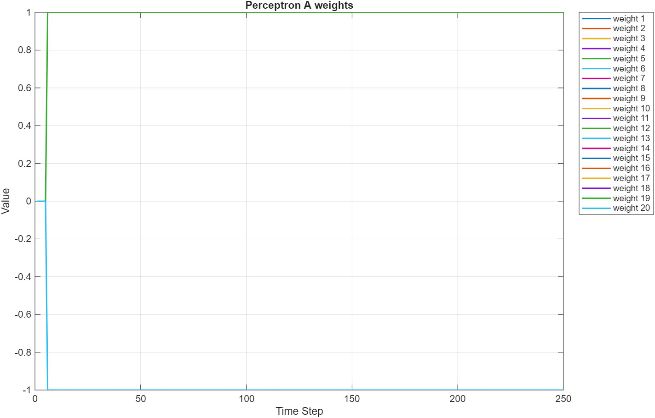

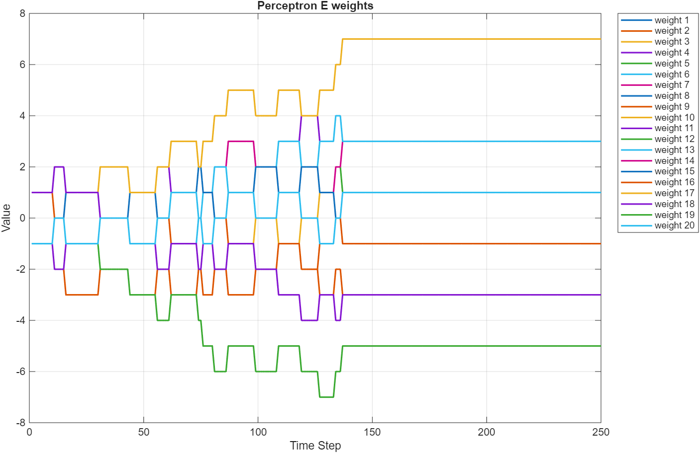

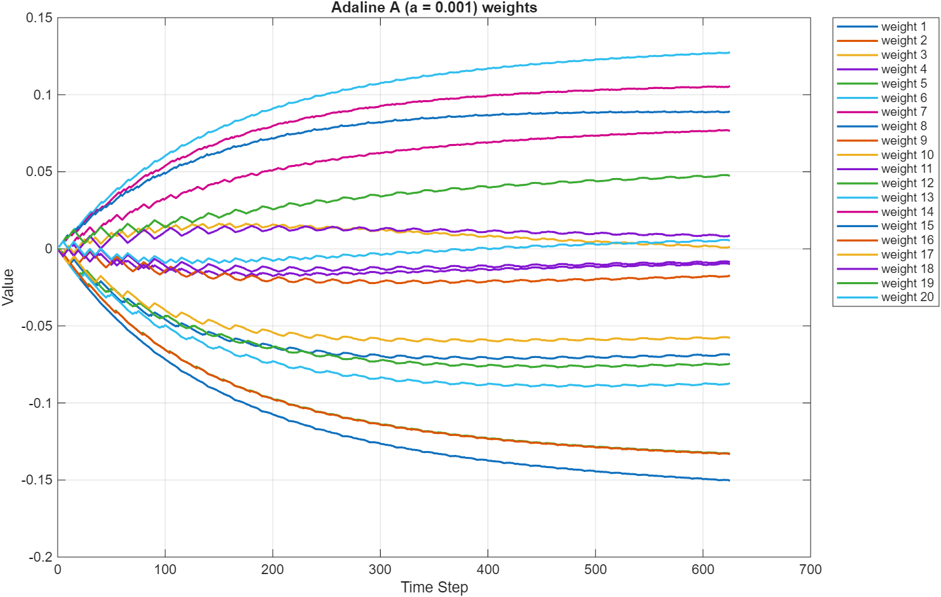
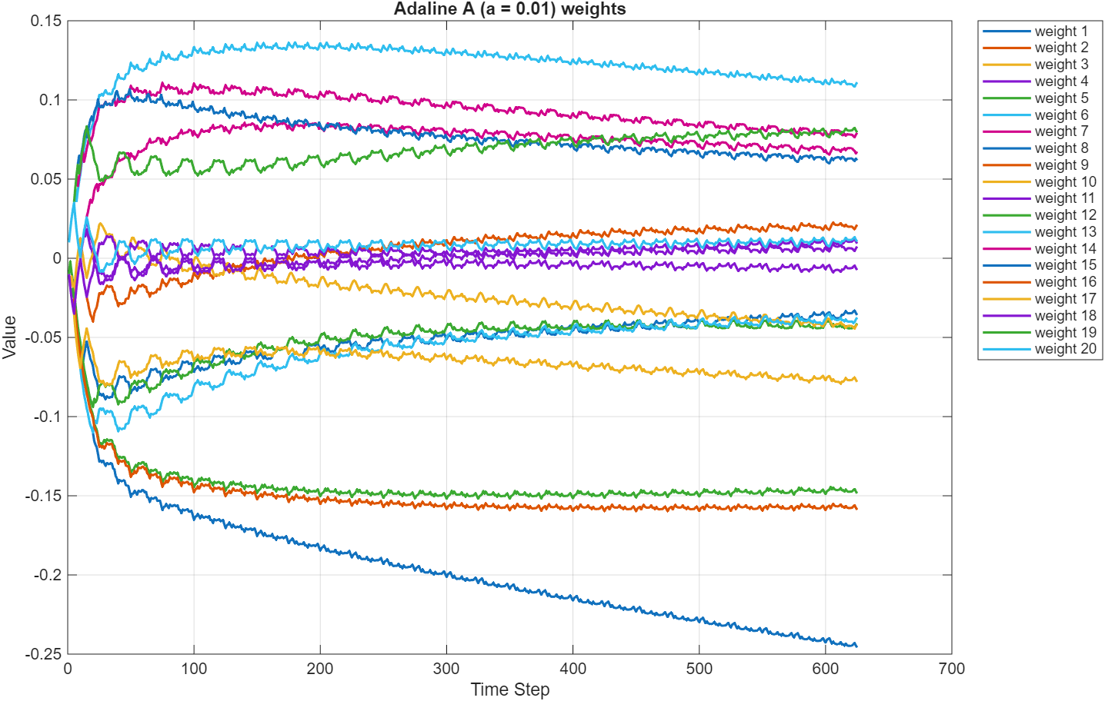
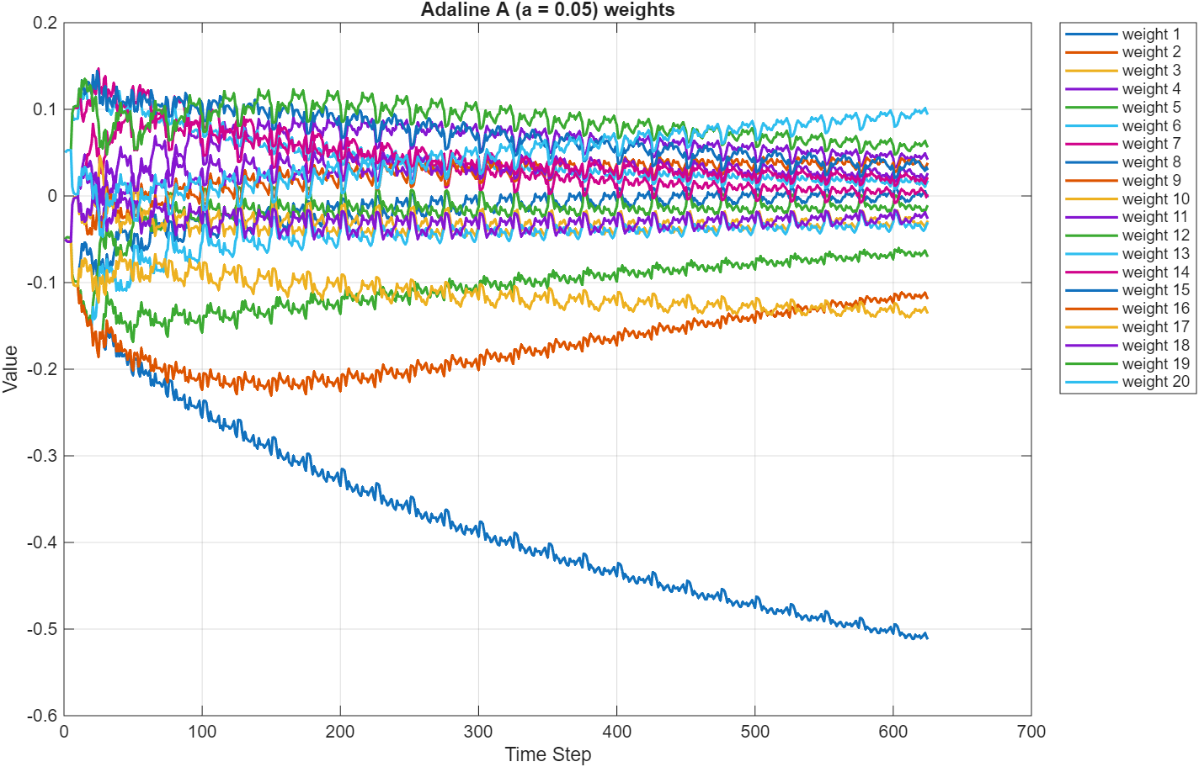

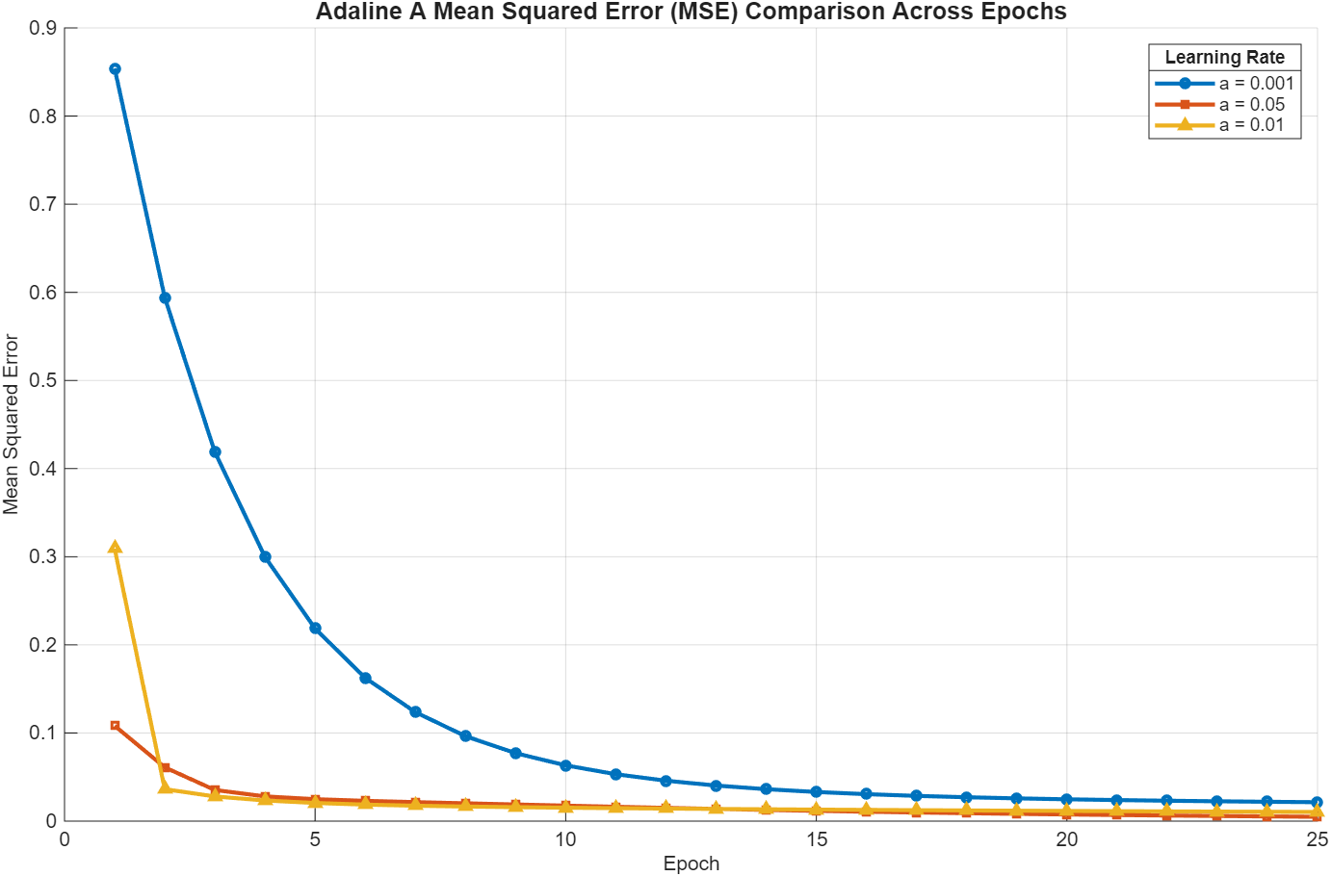
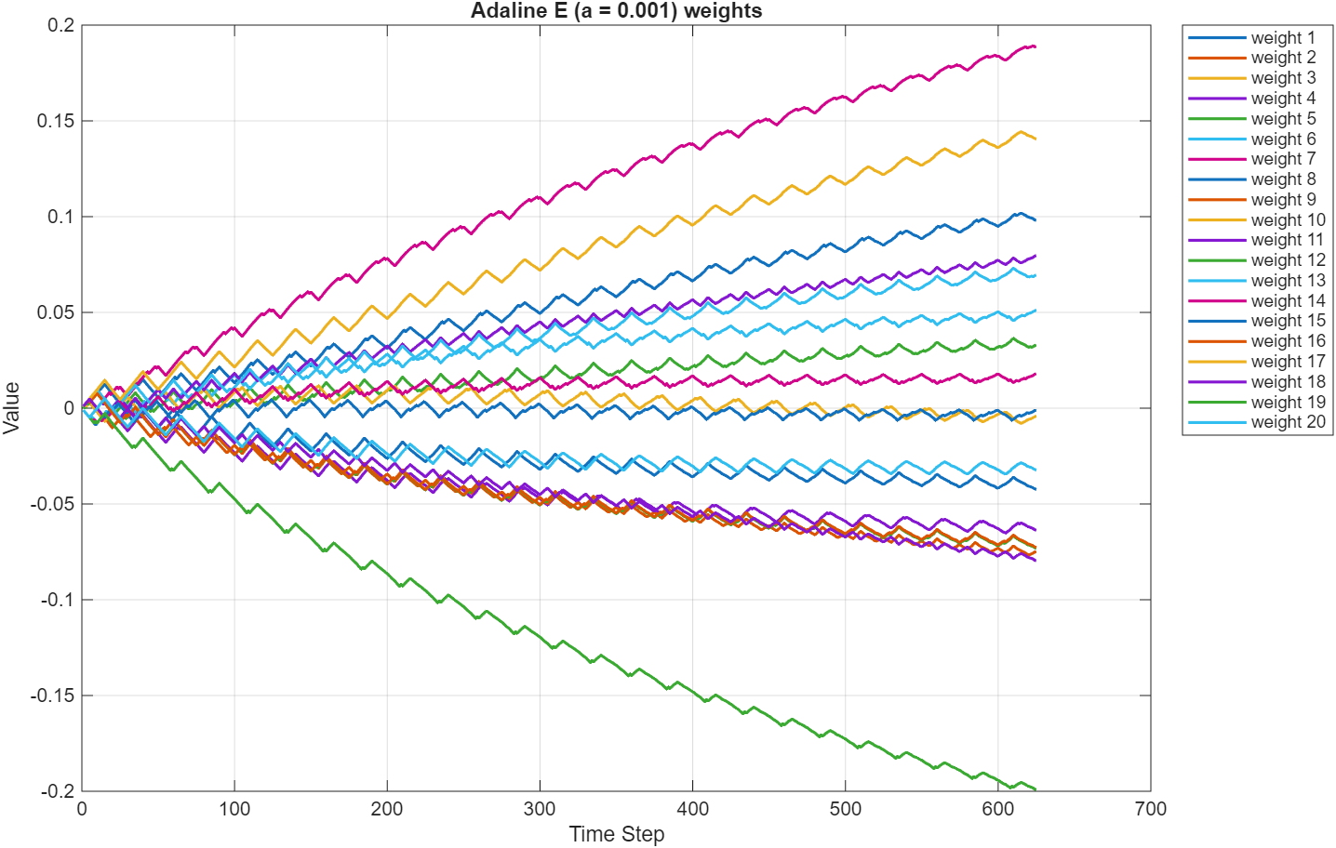
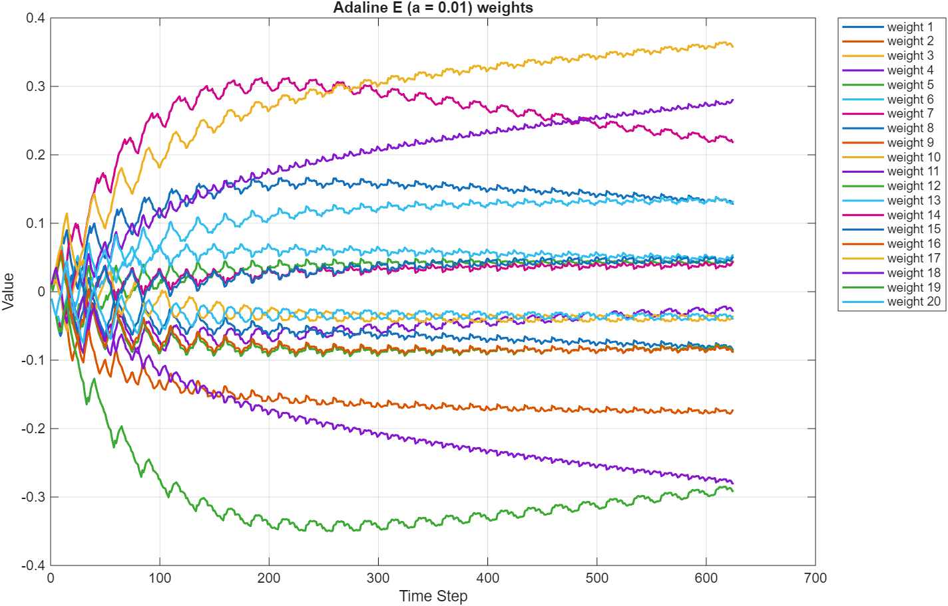
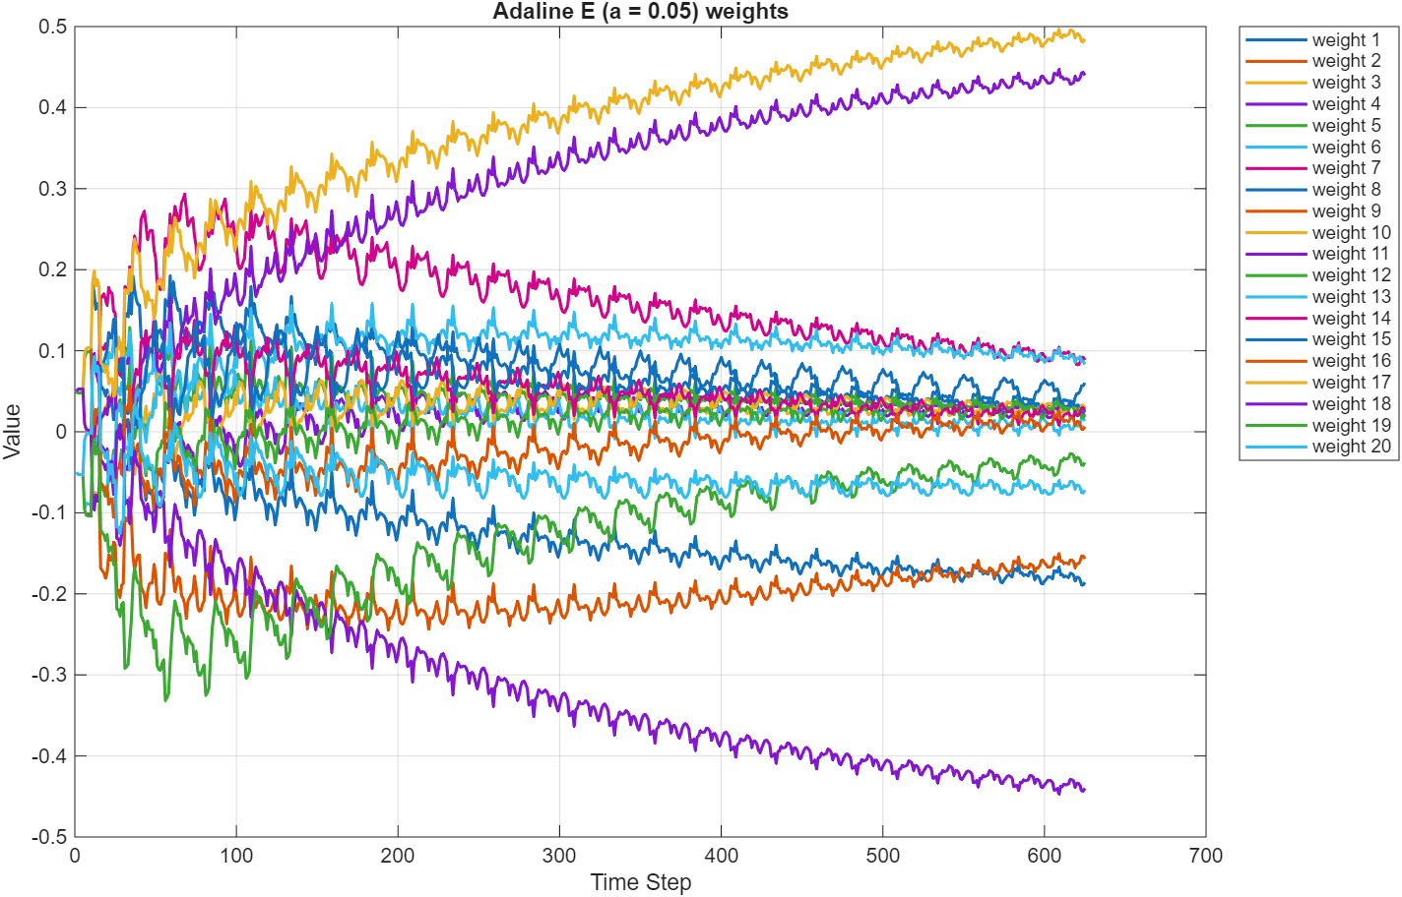
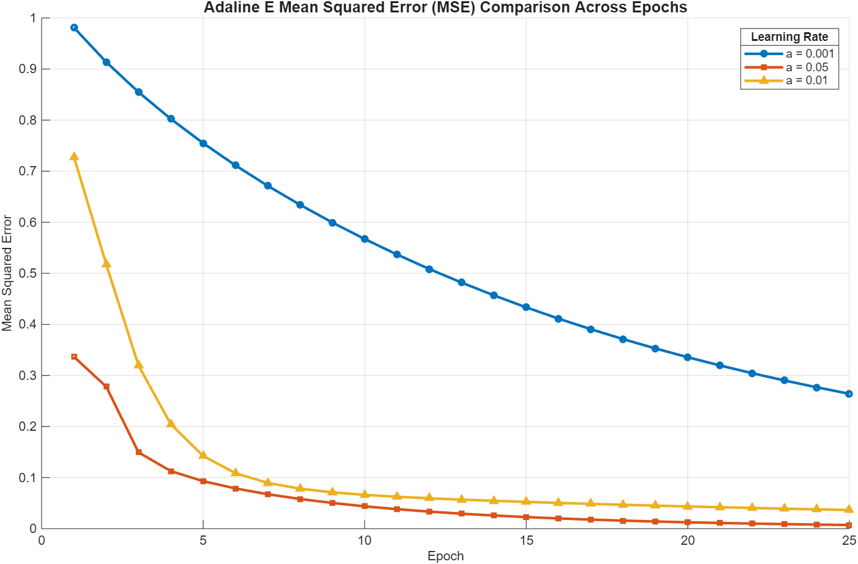

Test Data
A Perceptron
E Perceptron
A Adaline
E Adaline

Conclusion
My testing led to several interesting and unexpected results. I was surprised how accurately a single perceptron could come to learn the shape of letters, even if they are very low resolution.
I was also surprised to learn that the “A Detector” perceptron was able to learn the data in a single training step. I suspect this is due to the unique shape of the letter A. This model also had the best test performance of this project. This demonstrates that more complex architecture is not necessarily better than simply ones.

Appendix
Main project function
function [] = project1()

% create "A Detector" perceptron
ptron_A_weights = zeros(1,20, "double");
ptron_A_bias = 0;
% create "E Detector" perceptron
ptron_E_weights = zeros(1,20, "double");
ptron_E_bias = 0;

% create "A Detector" adaline perceptron
aline_A_weights = zeros(1,20, "double");
aline_A_bias = 0;
% create "E Detector" adaline perceptron
aline_E_weights = zeros(1,20, "double");
aline_E_bias = 0;

% learning rates Adaline
learningrateA1 = 0.001;
learningrateA2 = 0.05;
learningrateA3 = 0.01;

learningrateE1 = 0.001;
learningrateE2 = 0.05;
learningrateE3 = 0.01;

% load input & test data
load("PP-1.mat");
load("TA-1.mat");
load("TE-1.mat");

load("TST1-1.mat");
load("TST2-1.mat");
load("TST3-1.mat");

% train neurons
[ptron_A_weights, ptron_A_bias] = train_perceptron(ptron_A_weights, ptron_A_bias, PP, TA, 10, 0.5, 'Perceptron A weights')
[ptron_E_weights, ptron_E_bias] = train_perceptron(ptron_E_weights, ptron_E_bias, PP, TE, 10, 0.5, 'Perceptron E weights')

% adaline A
[aline_A1_weights, aline_A1_bias, aline_A1_mse] = train_adaline(aline_A_weights, aline_A_bias, PP, TA, 25, learningrateA1, 'Adaline A')
[aline_A2_weights, aline_A2_bias, aline_A2_mse] = train_adaline(aline_A_weights, aline_A_bias, PP, TA, 25, learningrateA2, 'Adaline A')
[aline_A3_weights, aline_A3_bias, aline_A3_mse] = train_adaline(aline_A_weights, aline_A_bias, PP, TA, 25, learningrateA3, 'Adaline A')

graph_meansquarederrors(aline_A1_mse, learningrateA1, aline_A2_mse, learningrateA2, aline_A3_mse, learningrateA3, "A")

% adaline e
[aline_E1_weights, aline_E1_bias, aline_E1_mse] = train_adaline(aline_E_weights, aline_E_bias, PP, TE, 25, learningrateE1, 'Adaline E')
[aline_E2_weights, aline_E2_bias, aline_E2_mse] = train_adaline(aline_E_weights, aline_E_bias, PP, TE, 25, learningrateE2, 'Adaline E')
[aline_E3_weights, aline_E3_bias, aline_E3_mse] = train_adaline(aline_E_weights, aline_E_bias, PP, TE, 25, learningrateE3, 'Adaline E')

graph_meansquarederrors(aline_E1_mse, learningrateE1, aline_E2_mse, learningrateE2, aline_E3_mse, learningrateE3, "E")

% decide which vesion of A and E adaline perceptrons are the best
% referencing the graphs, 0.05 seems to have the best performance

% test perceptrons
% first 5 are A, second 5 are E
A_truth = [1, 1, 1, 1, 1, -1, -1, -1, -1, -1, -1, -1, -1, -1, -1, -1, -1, -1, -1, -1, -1, -1, -1, -1, -1,];
E_truth = [-1, -1, -1, -1, -1, 1, 1, 1, 1, 1, -1, -1, -1, -1, -1, -1, -1, -1, -1, -1, -1, -1, -1, -1, -1,];

% a perceptron
[ATST1_results, ATST1_hitrate] = perceptron_test(ptron_A_weights, ptron_A_bias, TST1, A_truth, false);
[ATST2_results, ATST2_hitrate] = perceptron_test(ptron_A_weights, ptron_A_bias, TST2, A_truth, false);
[ATST3_results, ATST3_hitrate] = perceptron_test(ptron_A_weights, ptron_A_bias, TST3, A_truth, false);

test_table_display(ATST1_results, ATST1_hitrate, ATST2_results, ATST2_hitrate, ATST3_results, ATST3_hitrate, 'ptron_A_testResults.xlsx');

% e perceptron
[ETST1_results, ETST1_hitrate] = perceptron_test(ptron_E_weights, ptron_E_bias, TST1, E_truth, false);
[ETST2_results, ETST2_hitrate] = perceptron_test(ptron_E_weights, ptron_E_bias, TST2, E_truth, false);
[ETST3_results, ETST3_hitrate] = perceptron_test(ptron_E_weights, ptron_E_bias, TST3, E_truth, false);

test_table_display(ETST1_results, ETST1_hitrate, ETST2_results, ETST2_hitrate, ETST3_results, ETST3_hitrate, 'ptron_E_testResults.xlsx');

% a adaline
[alineATST1_results, alineATST1_hitrate] = perceptron_test(aline_A2_weights, aline_A2_bias, TST1, A_truth, true);
[alineATST2_results, alineATST2_hitrate] = perceptron_test(aline_A2_weights, aline_A2_bias, TST2, A_truth, true);
[alineATST3_results, alineATST3_hitrate] = perceptron_test(aline_A2_weights, aline_A2_bias, TST3, A_truth, true);

test_table_display(alineATST1_results, alineATST1_hitrate, alineATST2_results, alineATST2_hitrate, alineATST3_results, alineATST3_hitrate, 'aline_A_testResults.xlsx');

% e adaline
[alineETST1_results, alineETST1_hitrate] = perceptron_test(aline_E2_weights, aline_E2_bias, TST1, E_truth, true);
[alineETST2_results, alineETST2_hitrate] = perceptron_test(aline_E2_weights, aline_E2_bias, TST2, E_truth, true);
[alineETST3_results, alineETST3_hitrate] = perceptron_test(aline_E2_weights, aline_E2_bias, TST3, E_truth, true);

test_table_display(alineETST1_results, alineETST1_hitrate, alineETST2_results, alineETST2_hitrate, alineETST3_results, alineETST3_hitrate, 'aline_E_testResults.xlsx');

% perceptron training
function [weights, bias] = train_perceptron(init_weights, init_bias, patterns, targets, total_epochs, learning_rate, tablename)

% must be in project folder
% cd('')

weights = init_weights;
bias = init_bias;

% inputs are a 20x25 matrix. each column is a different pattern

[~,total_patterns] = size(patterns);

% preallocate tracking matrix
[~, sizey] = size(weights);
weights_history = zeros(25 * total_epochs, sizey, "double");

update_cycles = 0;
weight_adjustments = 0;

for currentepoch = 1:total_epochs

for c = 1:total_patterns
input = patterns(:,c);
input;

prediction = activate_perceptron( weights, bias, input );

error = targets(:,c) - prediction;
if error ~= 0
weight_adjustments = weight_adjustments + 1;
end

% adjust weights
[m,n] = size(weights);
for j = 1:n
old_weight = weights(:,j);

new_weight = old_weight + learning_rate * error * input(j);
weights(:,j) = new_weight;

end

% record result
index = c + total_patterns * (currentepoch - 1);
weights_history(index,:) = weights_history(index,:) + weights;

% adjust bias
bias = bias + learning_rate * error;
update_cycles = update_cycles + 1;
end
end

update_cycles
weight_adjustments

figure;
plot(weights_history, 'LineWidth', 1.5);

xlabel('Time Step');
ylabel('Value');
title(tablename);
labels = "weight " + (1:20);
legend(labels, 'Location', 'bestoutside');
grid on;

function [weights, bias, MSE] = train_adaline(init_weights, init_bias, patterns, targets, total_epochs, learning_rate, modelname)

% must be in project folder
% cd('')

weights = init_weights;
bias = init_bias;

% inputs are a 20x25 matrix. each column is a different pattern

[~,total_patterns] = size(patterns);

% preallocate tracking matricies
[~, sizey] = size(weights)
weights_history = zeros(25 * total_epochs, sizey, "double");
errors = zeros(total_patterns,1);
MSE = zeros(total_epochs,1,"double");

update_cycles = 0;
weight_adjustments = 0;

for currentepoch = 1:total_epochs

for c = 1:total_patterns
input = patterns(:,c);
weighted_sum = 0;

[prediction, weighted_sum] = activate_adaline( weights, bias, input );

error = targets(:,c) - weighted_sum;
if error ~= 0
weight_adjustments = weight_adjustments + 1;
end

% adjust weights
[m,n] = size(weights);
for j = 1:n
old_weight = weights(:,j);

new_weight = old_weight + learning_rate * error * input(j);
weights(:,j) = new_weight;

end

% record result
index = c + total_patterns * (currentepoch - 1);
weights_history(index,:) = weights_history(index,:) + weights;
errors(c) = error;

% adjust bias
bias = bias + learning_rate * error;
update_cycles = update_cycles + 1;
end

mse_currentepoch = mean(errors .^ 2);
MSE(currentepoch) = mse_currentepoch;
end

update_cycles
weight_adjustments

figure;
plot(weights_history, 'LineWidth', 1.5);

xlabel('Time Step');
ylabel('Value');
title( modelname + " (a = " + learning_rate + ") weights");
labels = "weight " + (1:20);
legend(labels, 'Location', 'bestoutside');
grid on;

% perceptron function with heavyside activation function
function [value] = activate_perceptron(weights, bias, input)

% calculate weighted sum
weighted_sum = weights * input + bias;

% calculate activation
if weighted_sum >= 0
value = 1;
else
value = -1;
end

% perceptron function with heavyside activation function
function [value, weighted_sum] = activate_adaline(weights, bias, input)

% calculate weighted sum
weighted_sum = weights * input + bias;

% calculate activation
if weighted_sum >= 0
value = 1;
else
value = -1;
end

function [results, test_hitrate] = perceptron_test(weights, bias, test_data, ground_truth, adaline)

[~,test_rowsize] = size(test_data);
correct = 0;
incorrect = 0;
false_positive = 0;
false_negative = 0;
results = zeros(size(ground_truth));

for pattern = 1:test_rowsize
input = test_data(:,pattern);

if adaline
prediction = activate_adaline(weights, bias, input);
else
prediction = activate_perceptron(weights, bias, input);
end

%
if prediction >= 0 & ground_truth(pattern) >= 0 | prediction < 0 & ground_truth(pattern) < 0
correct = correct + 1;
results(pattern) = 1;
end

if prediction >= 0 & ground_truth(pattern) < 0 % false positive
incorrect = incorrect + 1;
false_positive = false_positive + 1;
results(pattern) = -1;
end

if prediction < 0 & ground_truth(pattern) >= 0 % false negative
incorrect = incorrect + 1;
false_negative = false_negative + 1;
results(pattern) = -1;
end

end

% HR = Hit Ratio = # correct classifications / # attempted classifications = # correct classifications / 25
test_hitrate = correct / test_rowsize;
false_positive;
false_negative;

function [] = test_table_display(ATST1_results, ATST1_hitrate, ATST2_results, ATST2_hitrate, ATST3_results, ATST3_hitrate, filename)

TA1matrix = [ATST1_results, ATST1_hitrate; ATST2_results, ATST2_hitrate; ATST3_results, ATST3_hitrate;];
numCols = size(TA1matrix, 2);
colNames = "p" + compose("%02d", 1:(numCols-1));
colNames(numCols) = "Hit Rate";
TA1 = array2table(TA1matrix,"RowNames",{'Test 1','Test 2','Test 3'}, "VariableNames", colNames)

writetable(TA1, filename, 'WriteRowNames', true);

function [] = graph_meansquarederrors(mse1, learningrate1, mse2, learningrate2, mse3, learningrate3, letter)

total_epochs = length(mse1);
epochs = 1:total_epochs; % X-axis values

% --- Plotting ---
figure;
hold on; % Keep all lines on the same chart

% Plot each line with distinct markers and colors
plot(epochs, mse1, '-o', 'Color', [0 0.4470 0.7410], 'LineWidth', 2, 'MarkerSize', 4);
plot(epochs, mse2, '-s', 'Color', [0.8500 0.3250 0.0980], 'LineWidth', 2, 'MarkerSize', 4);
plot(epochs, mse3, '-^', 'Color', [0.9290 0.6940 0.1250], 'LineWidth', 2, 'MarkerSize', 4);

% --- Chart Styling ---
title('Adaline ' + letter + ' Mean Squared Error (MSE) Comparison Across Epochs', 'FontSize', 12, 'FontWeight', 'bold');
xlabel('Epoch', 'FontSize', 10);
ylabel('Mean Squared Error', 'FontSize', 10);

% Add a grid for readability
grid on;

% Label your specific lines in the legend
label1 = ['a = ', num2str(learningrate1)];
label2 = ['a = ', num2str(learningrate2)];
label3 = ['a = ', num2str(learningrate3)];

lgd = legend(label1, label2, label3, 'Location', 'northeast');
title(lgd, 'Learning Rate');

hold off;

